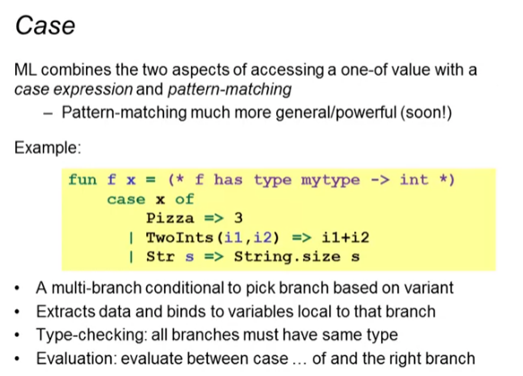

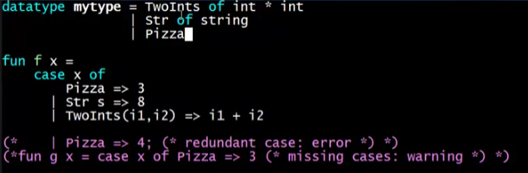

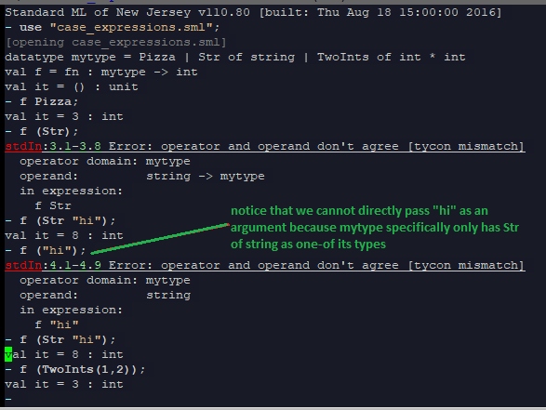

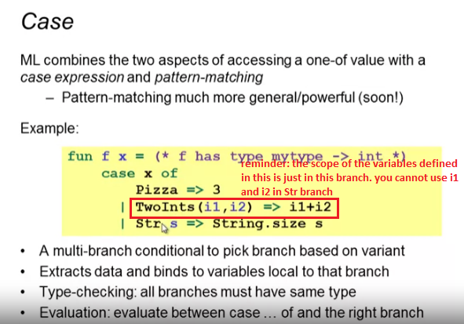

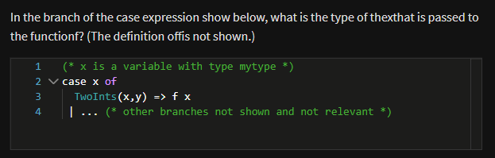

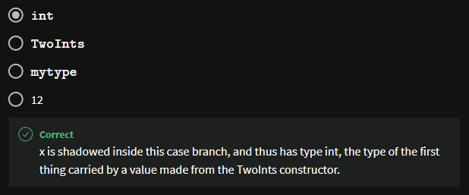

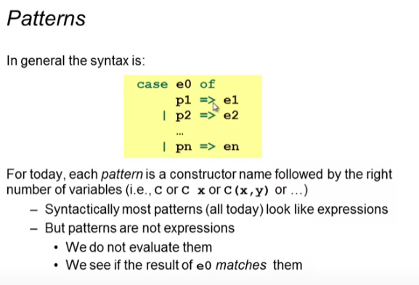

* Patterns are not expressions (rather than they are constructors)
  + WE DO NOT EVALUATE THEM
* They are something we are going to use to do the matching and introduce variable bindings for the CORRESPONDING branch only

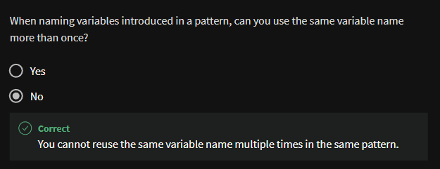

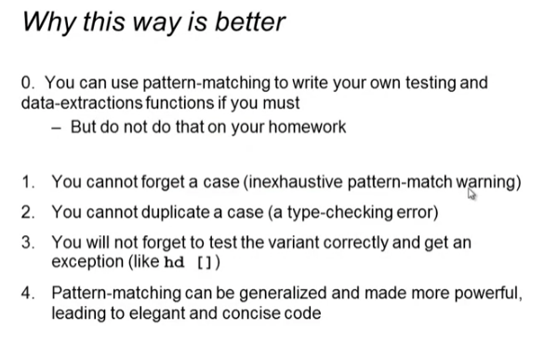

For reasons 1&2:

Duplicate case scenario:

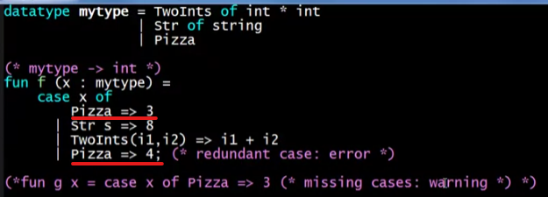

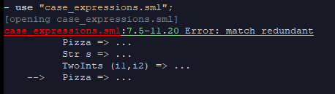

Forgetting a case:

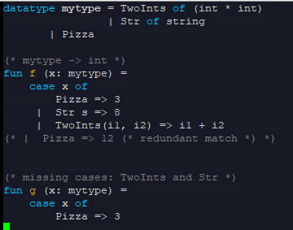

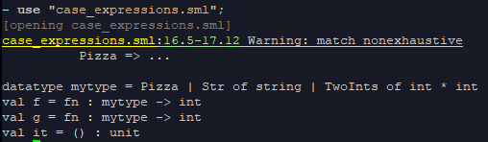

* Warning only! The app will still run but calling the cases that you forgot in function g will raise an exception:

